

#### **Assignment Cover Sheet**

|  |  |  |  |  |  |  |
| --- | --- | --- | --- | --- | --- | --- |
| **Student name:** | **Juraj Jarmek** | | | | | |
| **Student number:** | **2992196** | | |  | | |
| **Faculty:** | **Computing Science** | | |  | | |
| **Course:** | **Higher Diploma - Web Development** | | | **Stage/year:** | **1** | |
| **Subject:** | **Project** **– HDWD–P** | | | | | |
| **Study Mode:** | Full time | **x** |  | Part-time |  |  |
| **Lecturer Name:** | **Osama Abushama** | | | | | |
| **Assignment Title:** | **Project** | | | | | |
| **No. of pages:** |  | | |  | | |
| **Disk included?** | Yes | **x** |  | No |  |  |
| **Additional Information:** | (ie. number of pieces submitted, size of assignment, A2, A3 etc) | | | | | |
| **USB included** | | | | | |
|  | | | | | |
| Date due: | **14.06.2019** | | |  | | |
| Date submitted: | **13.06.2019** | | |  | | |
|  | | | | | | |
| **Plagiarism disclaimer:**  *I understand that plagiarism is a serious offence and have read and understood the college policy on plagiarism. I also understand that I may receive a mark of zero if I have not identified and properly attributed sources which have been used, referred to, or have in any way influenced the preparation of this assignment, or if I have knowingly allowed others to plagiarise my work in this way.*  *I hereby certify that this assignment is my own work, based on my personal study and/or research, and that I have acknowledged all material and sources used in its preparation. I also certify that the assignment has not previously been submitted for assessment and that I have not copied in part or whole or otherwise plagiarised the work of anyone else, including other students.*  **Signed:**  **Date: 13.06.2019** | | | | | | |

## **Please note:** Students **MUST** retain a hard / soft copy of **ALL** assignments as well as a receipt issued and signed by a member of Faculty as proof of submission.

**Project Report**

**Griffith College Dublin**

**HDWD-P**

**14th April 2019**

**INTRODUCTION**

Name of the website: Bad Guitars.

This is a full stack development project that we had to finish as the final project for our Higher Diploma in Science in Web Development course. I have built a fictional website called *Bad Guitars*, a guitar review website, inspired by the sites such as Reverb.com, Equipboard.com and Ultimate-guitar.com. I written the website in HTML, CSS, Bootstrap, jQuery, PHP, MySQL and ran it in XAMPP and phpMyAdmin to create CRUD (create, read, update, delete) functionalities in the backend and for the user interface in the front end.

The main objective of this project, besides from building a full stack website within a specified time frame was to simulate the work process of an actual full stack developer.

The website front end and foundation was built using HTML, CSS (Bootstrap) and jQuery (implemented with bootstrap) and included, headers, footers, navigation banner, login, logout, item images and a review section for the items.

**OVERVIEW**

**Home Page/Index**

This is the index.php page that I have made as the start site of the website. If we are not logged in, we will be redirected to the login page. First we are greeted with a simple dynamic greeting. From this page we have the options for the password reset and and logout. This is also the base of the website and we have inputted the same header in all the other pages of the website. The header includes the links for the homepage and for the album with the items that we can review. The site is also responsive so when we shrink the header it turns into a simple hamburger style menu.

**Log In**

This is the basic login form that will be shown to the user if they are not log in to the account and the user will be redirected to this page from any other page on the website.

The login form only asks for the username and the password. We are offered at the bottom of the page to register in case we do not have an account.

**Register**

If we do not have an account we make a new account in the register page. It is similar to the login page. We have the boxes for the username, password and confirmation of the password. Underneath are the submit button and the reset button for the form. If we already have an account there is a login button.

**Reset**

In the reset password page we can reset the password if we are logged in. We have only two sections for the new password and confirmation of the password. After we have reset the page, it leads us back to the login page.

**Log Out**

When we click on the logout button, it doesn’t lead us to a new page but just executes a function to destroy the session and redirect us to the login page.

**Album**

When we are logged in we can see the gallery with the guitars for review. They have a view button, so when we click on it, we are brought to the review page of the individual item. At the bottom of the page we have again the reset password and log out buttons.

**Product**

When we click on the view button we come to the individual product page. In the product page we have the image of the item and a short description of the item. We have then the button to add the new review.

**Create Record**

When we click on the add new review button we come to the create record page.

There it will record our username, which is given by the session and locked in in the back end and front end, and a rating from 1 to 5. When we leave our review we click on the submit button and it ads the review to the product page and we are redirected back to it.

**View Record**

When we click on the eye icon we can go into the read.php page and read the review in a larger format.

**Update record**

When we click on the pencil icon we are brought to the update record section where we can amend the details of an existing review.

**Delete Record**

When we click on the trash can icon we are brought to the delete section where we can delete the review. It asks us if we are sure if we want to delete the record. If we click no it brings us to the product page again without deleting the review, and if we click yes it will delete the record and bring us back to the delete page.

**User Groups**

For this demo we have built only one user group for simplicity. Further groups and permissions can always be added by adding a user type and specifying in a session which option can the user see as per their user type.

**SITEMAP AND WEBSITE FLOW**

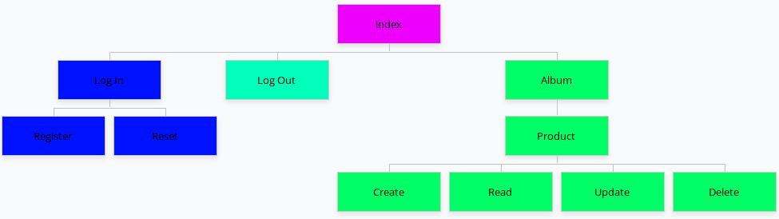

**WEBSITE APPEARANCE**

**Login**

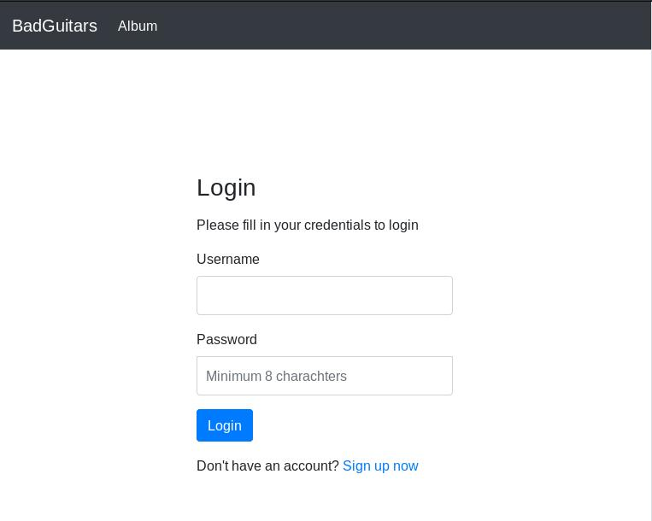

**Register**

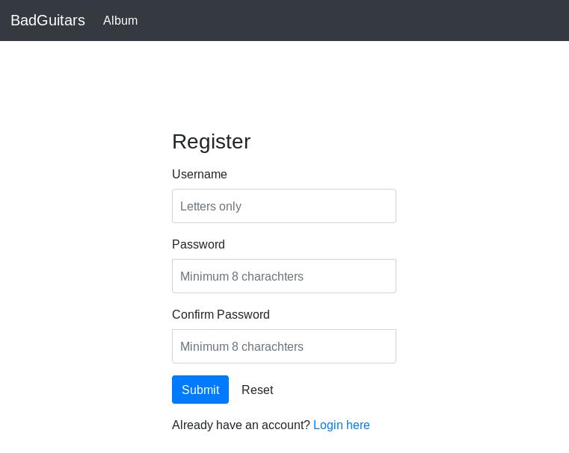**Index**

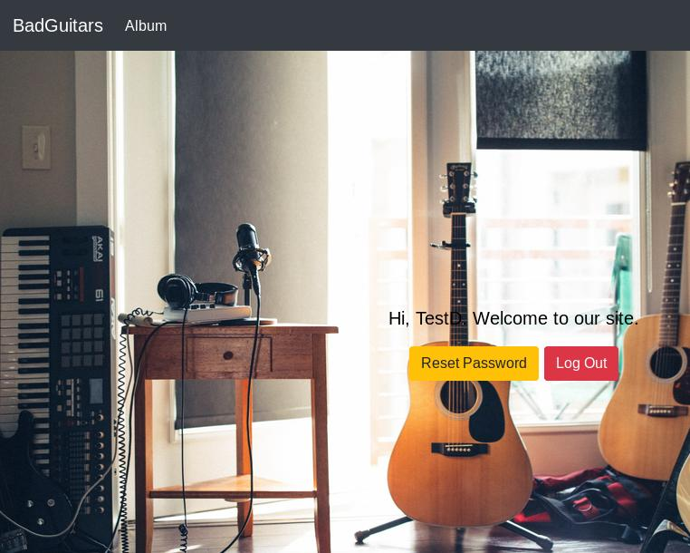

**Reset**

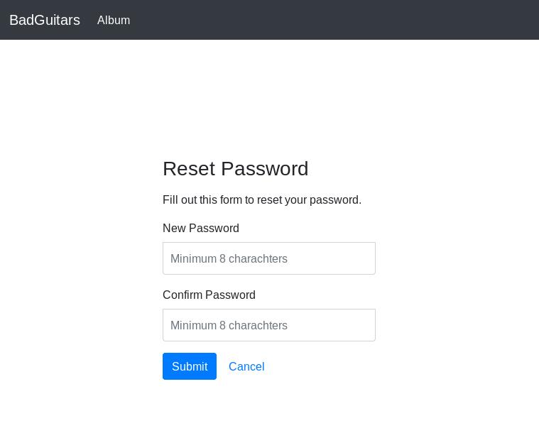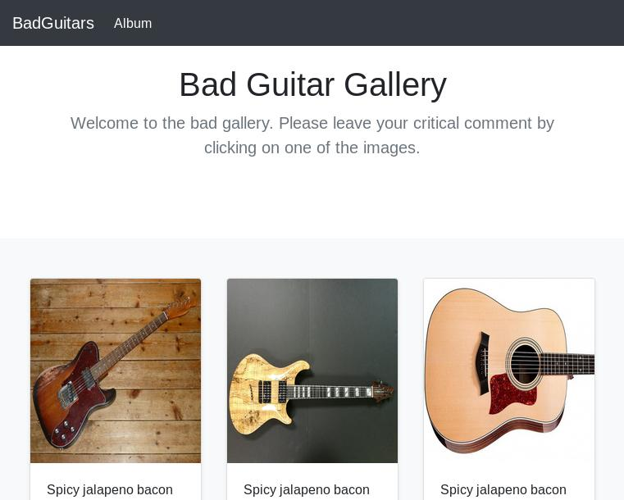**Album**

**Product**

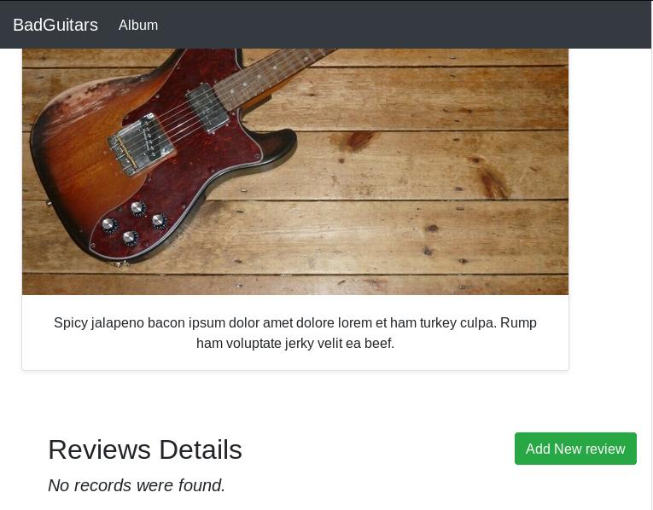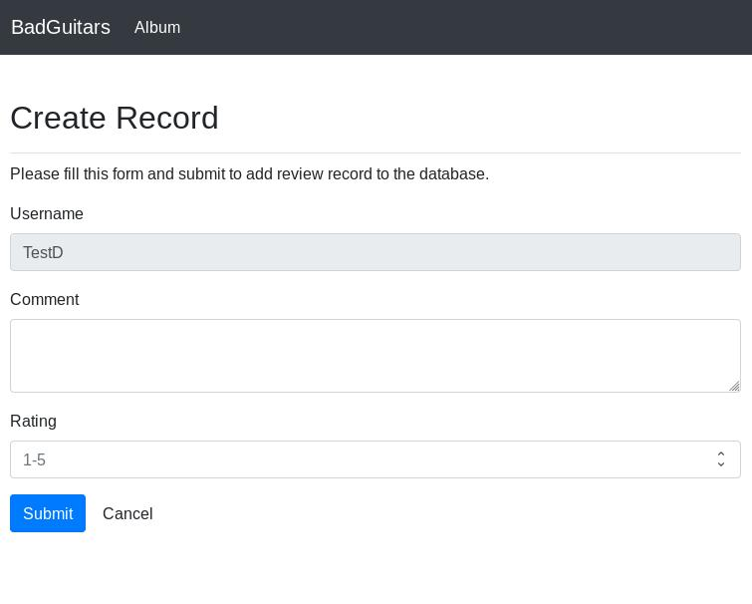**Create**

**Read**

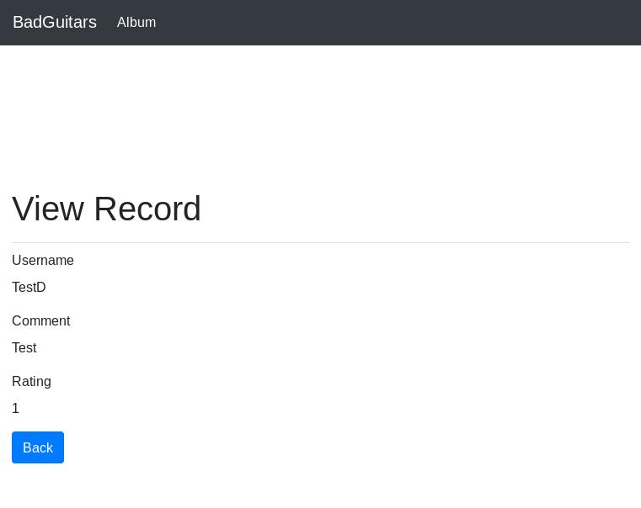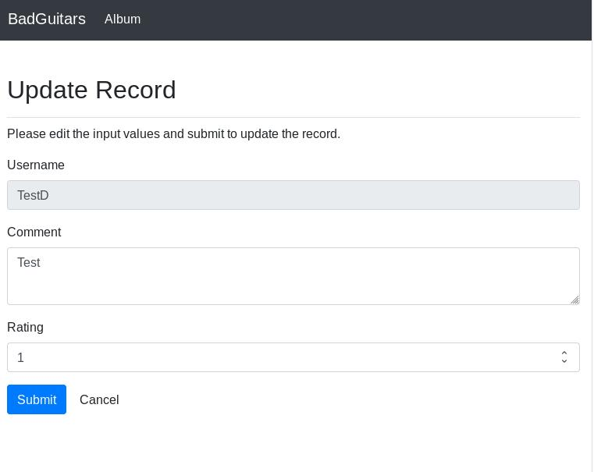**Update**

**Delete**

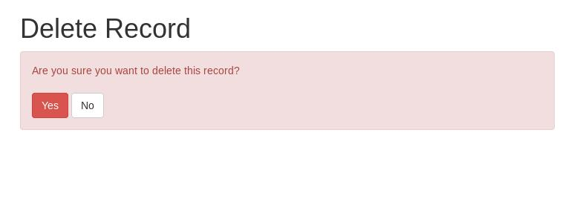**DATABASE DESIGN**

